PRESS RELEASE
DAN DRAYTON RACING
Date: 29th April Release Date: Immediate
Drayton in the points at the opening round of 2018
The opening round of the British Superbike Series was played out at the Donington Park Circuit, and the start to the season would be see severe weather warning issue, which brought snow, hail, torrential rain and sunshine. The circuit staff and trackside marshals braved the changeable conditions to ensure the racing schedule went ahead.
For Dan it would be his first time out in the Supersport Championship on the NP Motorcycles prepared Kawasaki ZX6R, he would go on to improve his lap times with each outing. The mixed weather was challenging for all the classes but Dan qualified with a respectable lap time, but was still a way off the pole position, after a few more changes to the bike setup the team were ready for the Sprint race; which takes place late on Saturday afternoon.
There was plenty of action packed into the 8 laps, and Dan made the best of the start consolidating that by moving up 8 positions to finish race one in fifteenth position; going straight into the points and placing him 16th on the grid for the feature race on Monday
Overnight and into Bank holiday Monday it was uncertain if the meeting would go ahead with more torrential rain, after many track inspections the Supersport riders were first onto a wet but drying track for warm up, Dan unfortunately left the racing line before falling on the last lap of warm up; giving the team only 90 minutes to repair and scrutineer once again before the race
The feature race was declared a wet race yet the track was drying quickly, Dan had retained wet tyres which would begin to degrade as the track dried Dan wasn't phased by the mixed conditions and he ran a solid race narrowly missing out on 13th position by 0.123 sec
Round 2 at Brands Hatch Indy soon came round, and the team were working hard to get the setup right for Dan, in trying to preserve funds for the season ahead the decision was made to worked hard on the suspension so Dan would get the best from the setup, rather than spending excessive monies to maximise the engine performance
Dan improved his lap times with every outing, but that would not reflect in his position at this short circuit, which soon becomes crowded giving little opportunity to pass.
In the sprint race on Saturday Dan had a fantastic race, and despite finishing in 23rd position he had some fantastic battles race long with Ryan Dixon and James Hillier.
Starting in 23rd Position for the feature race, Daniel worked hard to get into 19th position and had his sights set on the points once again. The organisers made the decision to red flag the race and declare a wet race and the grid would go back out for a 12 lap race restart. At that point the hard work was undone as the grid would be reformed on the original Grid positions.
As the re- start got underway Dan was in a tight pack and took several heavy contacts, by druids he found himself under the bike. Fortunately the quick reactions of the other riders ensured his injuries were minimal. The bike however was another story - suffering from much more than cosmetic damage.
Work began straight away to get everything ready for round three at Oulton Park 5th - 7th May
Dan comments:
I really enjoyed round one as I love the Donington circuit, the bike is not yet where we want it to be as we have had little time to test over winter, but I am happy to be in the points- though I know I have much more to give.
Brands Hatch Indy at Round two however was not very kind to me, unfortunately this has left the team - especially Neil -@NP Motorcycles with a large amount of work to do before Oulton Park
I will be focussing on my race preparation as we all pull together to ensure we get our best result we can at Round 3
If you would like to follow Dan why not visit his website: www.dandrayton.com
Image credits: Ian Hopwood Photography
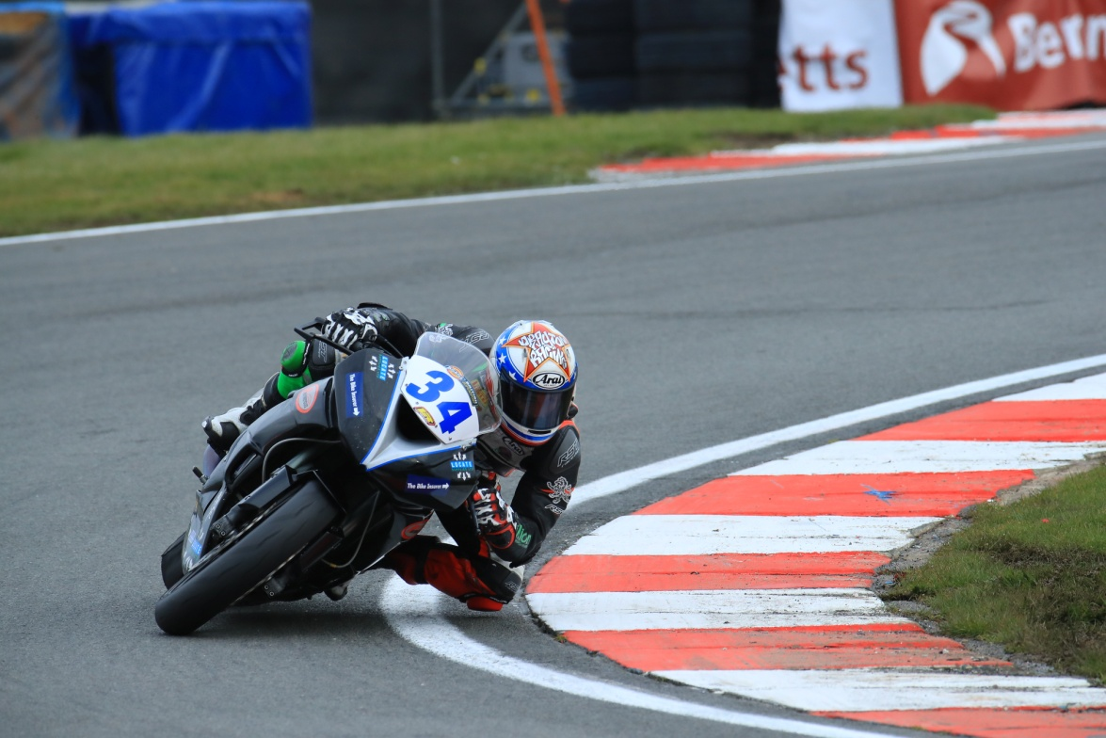
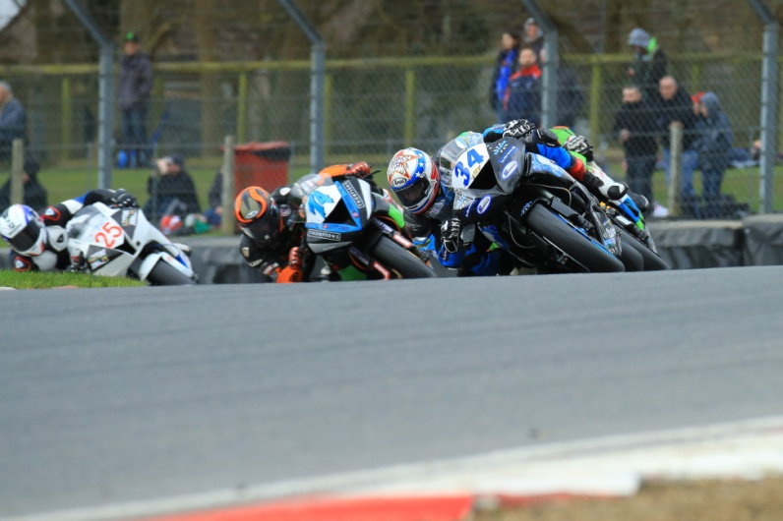

Press Release prepared by: K Drayton

